Christian Education Meeting Minutes

April 29th

Open in prayer

Confirmation of previous minutes

Children’s Church

* Summer children’s church
* Covered through August- we will have a break during August (except the last Sunday). Shelly sent announcement and slide to Bonnie.

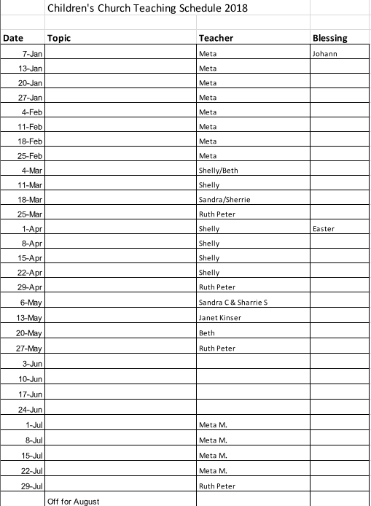

Awaiting confirmation on Skinners for June. Beth will do June 3.

Scholarships

Send to Bonnie; write up for bulletin; Ben Braskett will help connect servants with projects

Grad Sunday

* June 10th
* Bonnie managing Bibles
* Email Scott about Kim’s present and pictures
* Cake – Fellowship team and baskets- Sandi- to be set out after senior tea

**High School Graduates:**

**Payten Kaysner**

Graduates from Skyview High School

**Autumn Morin**

Graduates from Woodland High School

**College Graduates:**

**Beth Means**

Graduates from Warner Pacific University

**Kim Morin**

Graduates from Barclay College

Degree:  Bachelor of Psychology

Future Plans:

**Ben Skinner**

Graduates from Barclay College

Degree:  Bachelor of Pastoral Ministry

Future Plans: senior pastor of Georgetown Friends in Illinois

Thank you for volunteers

* November
* Crafts from kids and card or small gift
* Gift ideas

Next meeting: May 28th