Christian Education Meeting
9/24/17
Attendees:
X Johann Sonntag
Gretchen Roberts
X Beth Means
X Shelly Johnson

Item | Topic | Discussion | Participant
1 | Open in prayer  Minutes from previous meeting approved |  | Shelly  Minutes sent for approval via e-mail
2 | Children’s Church  CE Update | Updates on coverage:  November - December coverage is needed- begin recruiting now.  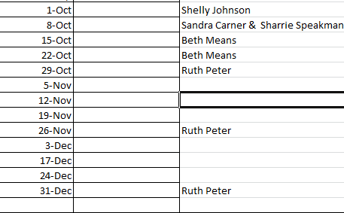  Team reviewed CE update powerpoint to be presented sometime in Octover | Team- please increase recruiting efforts this week.  Shelly will add  -Accomplishments  - Child protection policy- worked in alignment with Sandi, Rob, Toni to define list and connect people to complete training and background checks  -Children’s church recruiting  -Children’s church curriculum  -Acknowledge children’s bags  -Acknowledge Jamie’s work with adult Sunday School  -Camp scholarships
3 | Budget | Preliminary projections for next year’s budget (to be adjusted as needed after October budget report)  Curriculum: $200  Equipment and supplies: $200  Library: $100  VBS: $700  Youth Camp Scholarships: $1,000  General Expenses: $200  Background checks, training $500  Graduation Sunday: $500 | Beth to attend October business meeting and provide updates to team
Immediate action items: Fill children’s church teacher spots from Nov-Dec: Johann, Beth and Shelly make every effort to recruit.
Announcement: Power point in progress, target for presenting = October. Shelly and Beth would like to co-present.
Action items for future meetings:
Plan opportunities for trainings including during and after church
Plan recognition for volunteers

